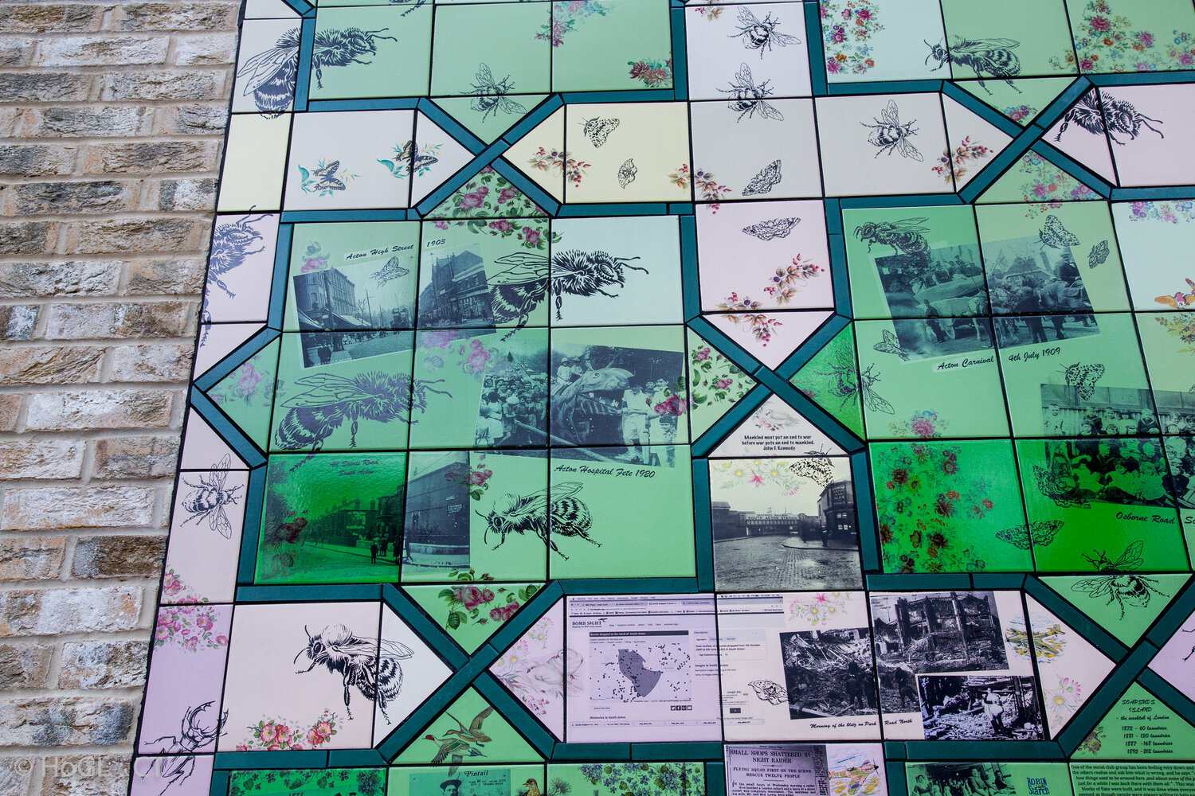

# **Greening Freeling Street**

Join an exciting initiative backed by Islington Council to turn Freeling Street into a mini park. Artist Carrie Reichardt will be helping us to create aa artwork to celebrate the people and events of Cally by printing local people’s designs, photos and artworks onto tiles, which we will use to make a mosaic.

We need images which stand out from a distance, words that inspire others and pictures that make all local people feel included.



.

**Send your drawings, photos & poems to**

**lucy@islingtonplay.org.uk**

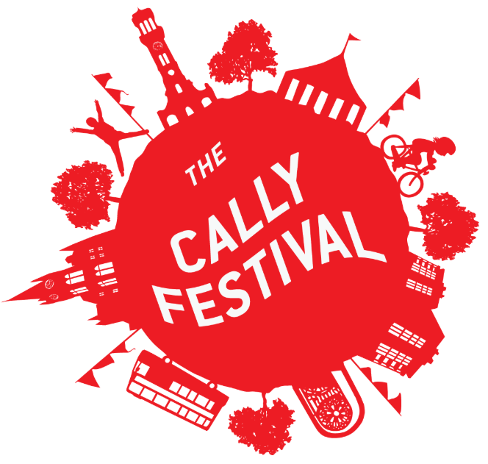

C:\Users\lucy\IPA\IPA Team Site - IPA\IPA 2020\Projects\Adventure Play 2020\freeling\mayor logo.png

